**VIT BUILD-A-THON**

**PROJECT REPORT**

**PROJECT TITLE:**

Build Personal translator application using Language Translation API with IBM Cloud

**TEAM MEMBERS:**

DINESH D

SAI PREETHAM

**INTRODUCTION:**

* 1. **OVERVIEW:**

Language Translator is a trend setter application which is built using NLP techniques, Using of the Language translators will be helpful for the lot of saving of the time and can easily able to understand any language in the world, Language translator will be converting the one text language to another text language which has the relevant and the same meaning for the provided text. Using of the translators can consume a lot time and ease of understanding by users is an advantage to the language translator, Translation is not a simple language replacement exercise; it is one of the main ways in which cultures shape political thought, literature, and science.

* 1. **PURPOSE:**

The purpose of the Language translator is to communicate of the any language to the users choice selected language which can feel to understand the text in the efficient way possible to the user, while due to the growth of the technology many people are eyed up on the smart devices so this is the right time to be implement the language translator which can be freely and easily understand by the smart users can replicable to communicate and understand every language which the users are connected globally with means of different languages but with the single meaning hence to find the behavioral patterns and meanings of the different users within the different languages will be connected by the language translators, so the purpose of the language translators are very crucial to make users happy.

**2. LITERATURE SURVEY**

**2.1 EXISTING PROBLEM**

Translation Studies is a field of study that deals with the theory, description, and application of translation. Because it examines translation both as an interlingual transfer, and as an intercultural communication, Translation Studies can also be described as an inter-discipline which touches on other diverse fields of knowledge, including comparative literature, cultural studies, gender studies, computer science, history, linguistics, philosophy, rhetoric, and semiotics.

The skills of translation are becoming ever more important and desirable. Today’s multicultural and multilingual society demands effective, efficient, and empathetic communication between languages and cultures. That’s important for various reasons, which we’ll now explore.

Effective, efficient, and empathetic translation requires highly skilled practitioners. Courses in Translation Studies are a great way for linguists, language graduates, and translators to develop a deep understanding of the academic field, and the skills to practice as a translation professional.

Translation enables effective communication between people around the world. It is a courier for the transmission of knowledge, a protector of cultural heritage, and essential to the development of a global economy. Highly skilled translators are key. Translation Studies helps practitioners develop those skills.

**2.1 PROPOSED SOLUTION**

In order to avoid manual language translation or seeking help of the language translator human we can make use of this language translator. If we are in a need to read other languages books we can scan them and convert those text and if we paste it in our web app it can translate it into the required language of the user so that the user can understand that easily. Just clicking the language required and within few seconds our app will translate it into required language.

**3. THEORETICAL ANALYSIS**

**3.1 BLOCK DIAGRAM**

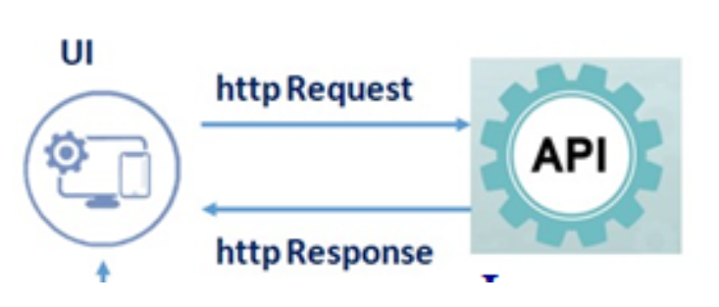

**3.2 HARDWARE AND SOFTWARE DESIGNING**

Hardware Requirements: Laptop/Pc

Software Requirements: Python, Anaconda Navigator, Jupyter Notebook, Spyder, Requests and Flask packages

**4. EXPERIMENTAL INVESTIGATION**

The first thing we need for this project is access to an api which we can integrate with our web application. Registering for RAPID API. Once it’s done, logging in into account and we can access all of the api’s available on the platform. We have choices to use the api’s for free but with many limitations. For full scale development, we can pay as per our demand and budget to get the most of the API. Then we have to subscribe to the desired API. Once clicked on Basic copy the code snippet under Python -> Requests and execute for testing the API.

**5. FLOWCHART**

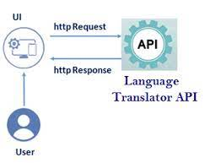

**RESULT:**

Screenshots of the output:

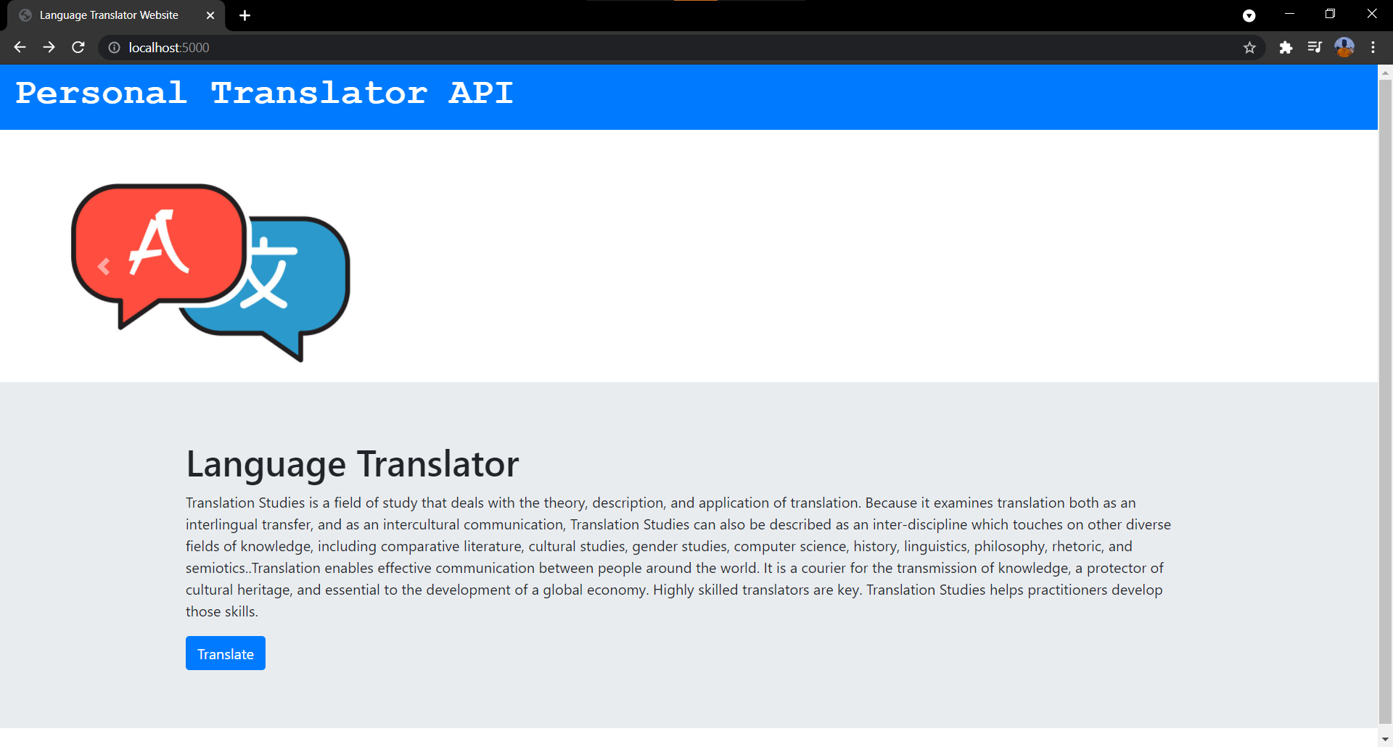

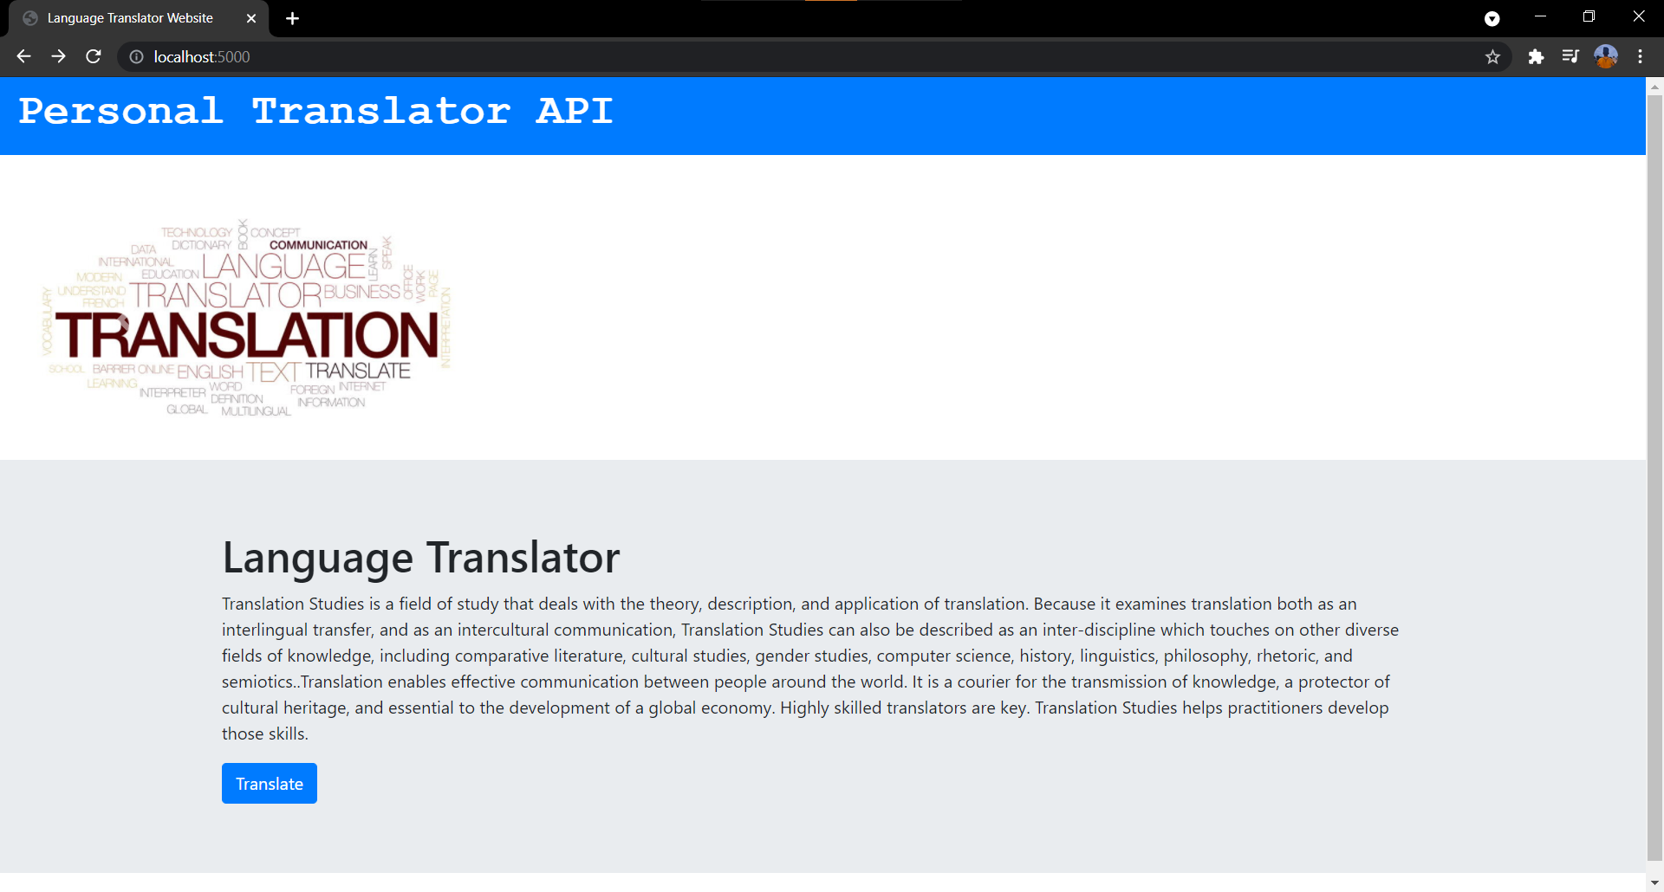

Entering the text and selecting language.

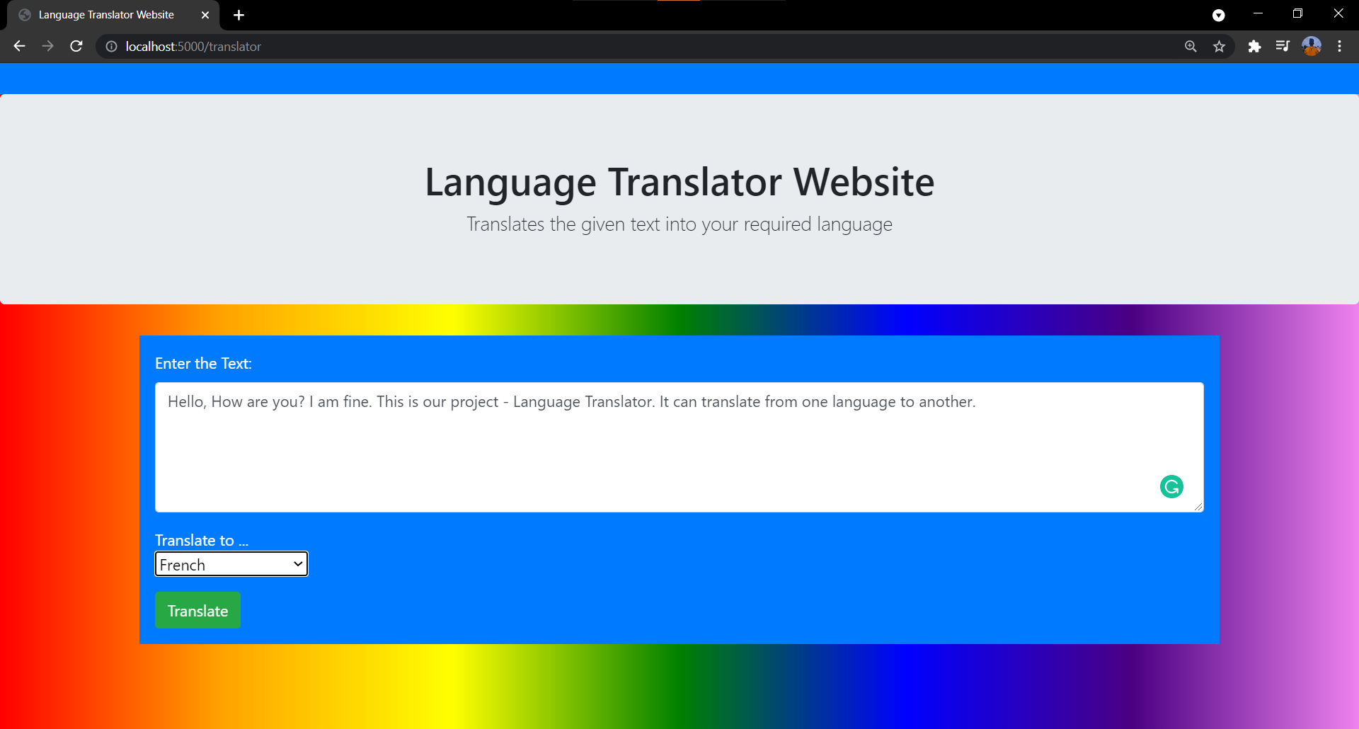

The entered text and the translated text are visible.

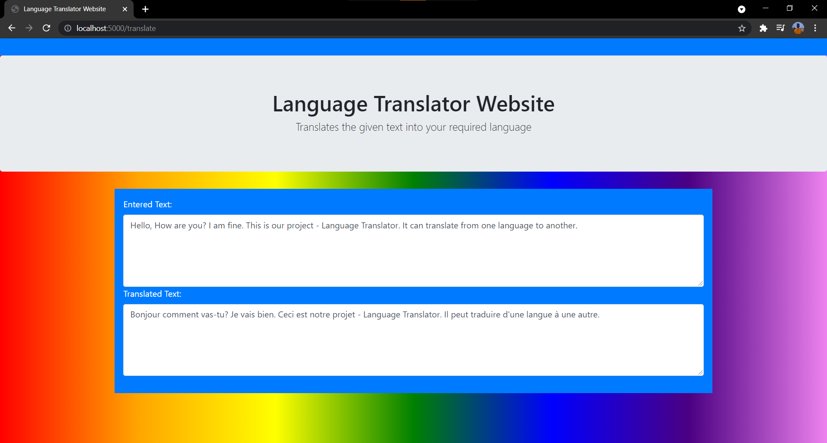

**ADVANTAGES AND DISADVANTEAGES:**

**Advantages:**

* Can increase the communication skills of various and vast languages present in the world
* Could be affordable in using with the multiple languages
* It will be meets the global expectation and the regulations of standards in the foreign countries
* Could be able to find the different people’s behaviors and patterns with the language translator and helps to share the information
* Effective communication helps to bring us many jobs and works hence with using this we can be communicate effectively with any language needed in the world

**Disadvantages:**

* While fetching the API from the rapid-fire application it will be little steadily slow for fetching the information using HTTPS
* While the Turnaround time might be longer when using language translator
* Unless we use the translation agency, with only the access to number of translators, we will be limited to the languages any one translator can work with the language translator
* Might be problem if the server side of the Fetching of API may fail to get the request if the lot of users are fetched at the same time in the narrow manner
* It would be really affects the language employees since it may reduce the jobs for the teaching field of different languages would be more crucial for the language speakers and teachers

**APPLICATIONS:**

* It is used in large vary sector in the communication of the foreign clients in the business meets
* While learning of the new language It would be really grateful of learning the language or course through this language translator
* Many people in the world without knowing the language can be easily communicated with the help of language translator
* Can helps in the making of the Robots translation machine
* Can be helps in the design of the automated NLP machine which produces the Speech recognition from one language to the other language

**CONCLUSIONS:**

Language translator helps many people in the way of communication, and meeting of business goals in the recent trends, and language translator would be more effective for the peoples communication with the other language persons and can helps to moderate the different scenarios of the users which makes very helpful in the finding the clues of behavioral trend patterns in persons career, and also can avoid the usage of routine dictionaries and can find the meaning in his comfort language helps to grab the words ,sentences and paragraphs effectively to the human brain ,hence the language translator is much useful and helpful tool which can be further used in the robotics and its applications

**FUTURE SCOPE:**

Future scope from the language translator is we can make the speech recognition translator which helps in the avoiding of writing the texts ,sentences, paragraphs instead can directly provide audio to the computer which is utilized by the microphone of the system and also helpful in the applications of robotics can be implemented using the NLP techniques which will be understands by the robots in the different languages of the entire world and can also provide the much effective website for the combination of the Speech and text language translators which world be more benefit to the users to select his own choice of translating the language

**BIBILOGRAPHY:**

RAPIDAPI SIGNUP: https://rapidapi.com/signup

SUBSCRIBING DESIRED API: https://rapidapi.com/cloud-actions-cloud-actions-default/api/language-translation

FLASK DEPLOYMENT: https://www.youtube.com/watch?v=WB-MIB_6SRc

**APPENDIX**

API – Application Programming Interface

HTTP – Hypertext Transfer Protocol

HTTPS – Hypertext Transfer Protocol Secure